Experiment No. 9

Samantha interviews many candidates from different colleges using coding challenges and contests. Write a query to print the contest_id, hacker_id, name, and the sums of total_submissions, total_accepted_submissions, total_views, and total_unique_views for each contest sorted by contest_id. Exclude the contest from the result if all four sums are .

**Note:** A specific contest can be used to screen candidates at more than one college, but each college only holds screening contest.

**Input Format**

The following tables hold interview data:

* Contests: The contest_id is the id of the contest, hacker_id is the id of the hacker who created the contest, and name is the name of the hacker.

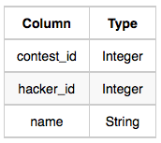

* Colleges: The college_id is the id of the college, and contest_id is the id of the contest that Samantha used to screen the candidates.

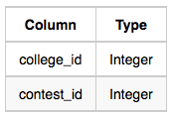

* Challenges: The challenge_id is the id of the challenge that belongs to one of the contests whose contest_id Samantha forgot, and college_id is the id of the college where the challenge was given to candidates.

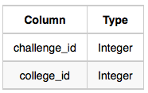

* View_Stats: The challenge_id is the id of the challenge, total_views is the number of times the challenge was viewed by candidates, and total_unique_views is the number of times the challenge was viewed by unique candidates.

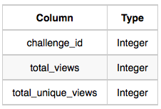

* Submission_Stats: The challenge_id is the id of the challenge, total_submissions is the number of submissions for the challenge, and total_accepted_submission is the number of submissions that achieved full scores.

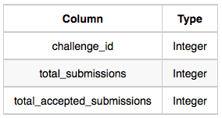

**Sample Input**

Contests Table:

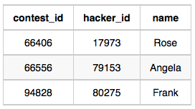

Colleges Table:

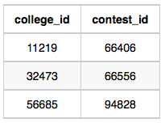

Challenges Table:

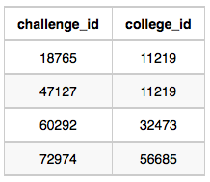

View_Stats Table:

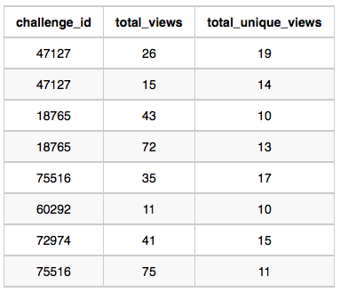

Submission_Stats Table:

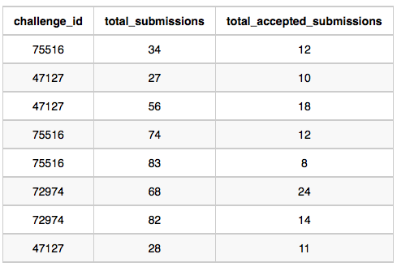

**Sample Output**

66406 17973 Rose 111 39 156 56  
66556 79153 Angela 0 0 11 10  
94828 80275 Frank 150 38 41 15

*To-Do:*

Write a query to print the contest_id, hacker_id, name, and the sums of total_submissions, total_accepted_submissions, total_views, and total_unique_views for each contest sorted by contest_id. Exclude the contest from the result if all four sums are 0 .

*Logic:*

create: select contest_id, hacker_id, name, and the SUM(total_submissions), SUM(total_accepted_submissions) FROM Submission_Stats table

and create another table: select challenge_id, SUM(total_views), SUM(total_unique_views) FROM View_Stats table

and then join these two tables with Contests, Colleges, and Challenges tables, filter the sum of all fours > 0 and order by contest_id

*Solution:*

SELECT con.contest_id, con.hacker_id, con.name, SUM(sg.total_submissions), SUM(sg.total_accepted_submissions),  
SUM(vg.total_views), SUM(vg.total_unique_views)  
FROM Contests AS con   
JOIN Colleges AS col  
ON con.contest_id = col.contest_id  
JOIN Challenges AS cha   
ON cha.college_id = col.college_id  
LEFT JOIN  
(SELECT ss.challenge_id, SUM(ss.total_submissions) AS total_submissions, SUM(ss.total_accepted_submissions) AS total_accepted_submissions FROM   
Submission_Stats AS ss GROUP BY ss.challenge_id) AS sg  
ON cha.challenge_id = sg.challenge_id  
LEFT JOIN  
(SELECT vs.challenge_id, SUM(vs.total_views) AS total_views, SUM(total_unique_views) AS total_unique_views FROM View_Stats AS vs GROUP BY vs.challenge_id) AS vg  
ON cha.challenge_id = vg.challenge_id  
GROUP BY con.contest_id, con.hacker_id, con.name  
HAVING SUM(sg.total_submissions)+  
 SUM(sg.total_accepted_submissions)+  
 SUM(vg.total_views)+  
 SUM(vg.total_unique_views) > 0  
ORDER BY con.contest_id;